MODULE 2 : PRODUCTION SYSTEMS

STUDENTS’ FACTSHEET

INTRODUCTION
There are a substantial number of beef production systems, and it is possible to divide them into two definite categories, namely,
- Structured systems
- Less structured systems.
Structured systems have a clear pattern, defined by the type of animal used (breed, gender, age) time of year, husbandry and type of feed. Less structured systems are usually much more flexible, using many types of animals on similar feed.
Features of a Structured System
- A specific breed or cross is used e.g. A dairy and beef cross in an 18month system.
- A specific gender is used eg. Bull calves from the dairy herd in a barley system.
- The system will begin with calves of a particular age for a particular period eg. Week old calves in Autumn with an 18 month system.
- A routine husbandry pattern based on a season of the year
- Specific feeds eg. Silage with a Rosemaund sysem
- Specific marketing periods
Features of a Less Structured System
- Use of a variety of aniamls
- Based on one type of feed e.g, finishing on grassland, finishing on silage and concentrates
- Flexible rearing period, and a flexible marketing period.

index

Spring | Time of year
Powdered milk, silage and concentrates dwysfwyd | Feed and nutrition
40-50 Kg | Weight target
0.7 Kg/daily @ 90 days | Growth target and number of days
Calves from the dairy herd | Activity and notes

structured systems

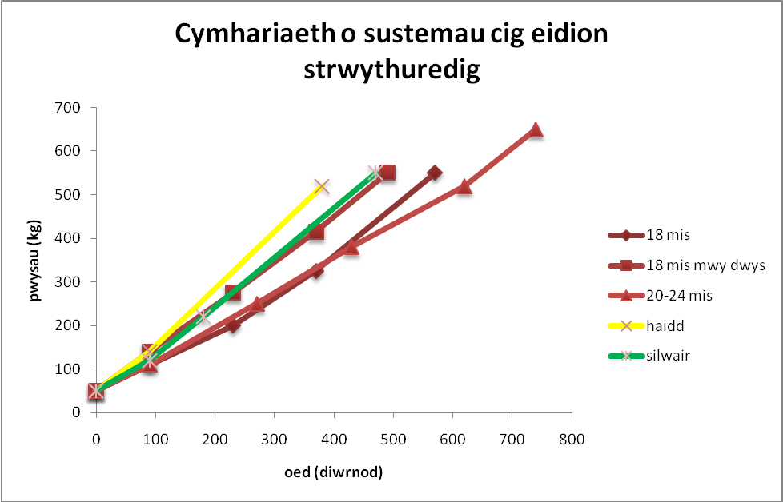
Figure 1 weight comparison against age in structured beef systems
Animals on different systems have different growth rates. Although the breed itself is a factor, the main factor is the nutrition introduced into the concentrates and feed (MJME/kgDM ). Usually, animals with higher amounts of concentrates in their diet have a higher growth rate over a shorter period, and, subsequently, a higher day growth rate.
Example
When we compare the details of the barley system with the 18 month system, we can see that higher level of nutrition is built up on a higher day growth in a barley system, compared with the 18 month system (see Table 1 below).

 | Barley System | 18 month system
Initial weight (kg) | 50 | 50
Feeding period (days) | 365 | 540
Final Weight (kg) | 520 | 550
Day growth (kg per day) | 1.29 | 0.93
Notes | - Shorter feeding period (-175 dydd)  - Lighter final weight (-30 kg)  - Higher day growth (+0.36 kg per day) | - Longer feeding period (+175 days)  - Heavier final weight (+30 kg)  - Lower day growth (-0.36 kg per day)
Table 1 weight, feeding period and growth of two beef producing systems

traditional 18 months
Autumn
Winter
Spring
Summer
Autumn
Winter
Spring
Calves from the dairy herd
Indoor Wintering
Turn out in May
Grazing
Indoor Wintering
Marketing and slaughter
Powdered milk, silage and concentrates high in protein
Silage and concentrates
Grass
40-50 Kg
200 Kg
325 Kg
550 Kg
110 Kg
(reared)
0.7 Kg/day @ 90 days
0.75 Kg/daily @ 140 days
0.9 Kg/daily @ 140 days
1.1 Kg/daily @ 200 days
Siage and concentrates (2-6 Kg daily)
18-21 months
MORE INTENSIVE 18 months
Autumn
Winter
Spring
Summer
Autumn
Winter
Calves from the dairy herd
Indoor wintering
Turn out in May
Grazing
Indoor wintering
Marketing and slaughter
Powdered milk, silage and concentrates high in protein

Silage and concentrates
Grass
40-50 Kg
275 Kg
415 Kg
550 Kg
140 Kg
(reared)
1.0 Kg/day @ 90 days
1.0 Kg/day @ 140 days
1.0 Kg/day @ 140 days
1.1 Kg/day @ 120 days
Silage and concentrates (4-8 Kg/day)
16-20 months
Notes on the 18 month system
- The 18 month system was developed so that the abundance of male calves produced by a dairy herd calving in autumn could be put to good use, and in order to sell them in spring - in 18 months – when beef prices are traditionally higher;
- The animals feed on grass during the growing period, and on silage and concentrates during winter. If the silage is of low quality, more concentartes will have to be fed. This will make the system less profitable – therefore good quality silage is essential to the succes of this system;
- A more intense 18 month system uses cross dairy and beef calves e.g. Charolais x, Limousin x, which has a higher day growth rate (kg per day). This could mean that the animals are heavier when ready to sold, compared to pure dairy calves, or could be sold earlier in spring when they are 16-18 months old;
- Since the 1970s, the Holstein influence has increased in dairy herds at the expense of the Friesian. This resulted in poor quality carcass as the angular traits, advantageous to a dairy animal, became more apparent at the expense of the more rounded traits of the Friesian – this would be more suitable for some beef systems. As a result, pure male dairy calves became unsuitable for the 18 month system.
- Further Information
  - Practical Beef Cattle Nutrition- Meat Promotion Wales http://www.hccmpw.org.uk/medialibrary/publications/Maethu%20Gwartheg%20Cig%20yn%20Ymarferol.pdf tud. 7-13
  - Beef Producer’s Handbook “From Gate to Plate” – Meat Promotion Wales http://www.hccmpw.org.uk/medialibrary/publications/Beef%20producers%20handbook%202010%20Cym.pdf

20-24 months
Autumn
Summer
Autumn
Winter
Spring
Autumn
Winter
Spring
Summer
Calves from the dairy herd
Indoor wintering
Turn out in May
Grazing
Indoor wintering
Marketing and slaughter
Powdered milk, silage and concentrates high in protein

Silage and concentrates
Grass
Silage and concentrates (2-6 Kg/day)
Indoor wintering (store period)
Turn out in April
Grazing
Grass
Silage and concentrates if needed
40-50 Kg
250 Kg
380 Kg
110 Kg
(reared)
0.7 Kg/day @ 90 days

0.8 Kg/day @ 180 days

0.8 Kg/day @ 160 days
1.1 Kg/day @ 120 days
520 Kg
0.7 Kg/day @ 190 days
650 Kg
20-24 months
Notes on the 20-24 month system
This is a system over an extended period, and it is less common now because of the initial capital needed to establish it. The profits are often not enough to clear the loan capital over a two-year period.
- However, the system could operate on two different farms, one farmer selling the animals as store and the other finishing them for the slaughter market. This would share the cost of a functional loan capital and bring in income earlier for the first farmer.
- The system would depend upon suitable pastures for growing silage. The animals most at risk of developing worms, usually the younger calves, would graze before the remainder.
- Very often, a system such as this would utilize compensatory growth after the animals have been on a store period during the second winter.
- Further information
  - Making the Most of your Finishing Beef Cattle – Meat Promotion Wales http://www.hccmpw.org.uk/medialibrary/publications/Gwneud%20y%20Gorau%20o'ch%20Gwartheg%20Eidion%20sy'n%20Gorffen%20Pesgi.pdf
  - Beef Producer’s Handbook “From Gate to Plate” – Meat Promotion Wales http://www.hccmpw.org.uk/medialibrary/publications/Beef%20producers%20handbook%202010%20Cym.pdf

barley

Birth
3 months
6 months
9 months
Powdered milk, silage and concentrates high in protein

40-50 Kg
140 Kg
(reared)
1.0 Kg/day @ 90 days
Barley
(ad libitum)
a straw
520 Kg
1.3 Kg/day @ 290 days
Calves from the dairy herd
Indoors
Marketing and slaughter
12-14 months
Notes on the Barley System
- This system was developed at the time when protein from crops – especially barley – was comparatively cheap, and protein from animals – beef - much more valuable. Even today, financial success of the system depends on the difference between the cost of buying barley and the price of beef in the market.
- Bulls are used with this system to sustain a high, daily growth and produce carcass with less body fat. The dairy breeding sires’ temperament and the law (Wildlife and Countryside Act 1981) mean that the animals are kept indoors permanently. It also means a hefty investment in buildings and feeding structures. Feeding structures will have to allow animals to be fed from outside their pens.
- Because the animals are permanently indoors, it is possible to run such a system throughout the year.
- It is suggested that there should be no more than 20 animals per pen, and there should be a 100-160mm space per head in the feeding troughs. Therefore in a pen holding 20 animals, there should be a trough that is 2000-3200mm (2.0-3.2m) long.
- The animals are fed a mixture of barley, other cereals and soya, ground ad libitum. The protein should be 15-16% of the concentrates until the animal weighs 300kg, then 14-15% thereafter. It should be possible to include some feed similar to maize gluten and brewery grain to reduce feed costs. Straw will also be available to help the rumen, and, more importantly to prevent acidosis. The animals shouldn’t run out of food, as this would impair the rumen’s pH and decrease their daily growth.
- Bulls from a barley system are not sent to a live market but go directly to a slaughter-house. Usually there will be an active liaison between the slaughter-house and the farmer to ensure that bulls are under no stress when transported from farm to slaughter-house. A wild temperament and stress could reduce the quality of the meat and produce dark cutting beef that is unaccpetable to the customer.
- Further information
  - Bull Beef – Meat Promotion Wales
  - Beef Producer’s Handbook “From Gate to Plate” - Meat Promotion Wales http://www.hccmpw.org.uk/medialibrary/publications/Beef%20producers%20handbook%202010%20Cym.pdf

Notes on the Silage (Rosemaund) / MAIZE SILAGE SYSTEM
Geni
3 mis
6 mis
9 mis
12 mis
15 mis
Powdered milk, silage and concentrates high in protein
40-50 Kg
550 Kg
120 Kg
(reared)
1.0 Kg/day @ 90 days
1.1 Kg/day @ 290 days
Bull calves from the dairy herd fuches odro
Notes on the silage system(Rosemaund) / maize system

- Cattle on the silage system will be permanently indoors, and will feed on silage and concentrates, according to appetite.
- Since the aim is to produce high-quality silage (67+ D Value, 10.5-11.0 MJME/kgDM and protein 120-180 g/kg) grasslands will be managed to allow 4 cuts or more during the growing season. Therefore, such a system needs comparatively fertile lowlands, and an extended grass growing season, where the temperature is higher than 6 degrees Celsius most of the year, and to allow machinery on the fields early and late in the year.
- If bull calves are used in this system, then 15 months old is the limit before putting on more fat and reducing carcass quality.
- In continental Europe, the maize silage system is one of the most common for finishing beef. Maize is a continental crop, and needs many hours of sunshine to reach its output potential. A maize crop consisting of 30% dry matter and 30% starch would be suitable, but the protein level would be low. Therefore, supplementary protein needs to be given to the animal.
- This system’s advantage is having total management of nutrition, and, as the animal is not grazing, there is no direct infection by worms, or indirect infection, as the acid in the silage kills the eggs.
- Nevertheless, there will need to be a substantial investment in machinery and feeding infrastructure, especially to store silage. The silage-pit face has to be relatively narrow, to reduce the exposed surface area, and reduce oxidation which would lower silage quality.
- Further information
  - Bull Beef – Meat Promotion Wales

Less structured Systems

Finishing on grass (summer and autumn)
Autumn
Spring
Summer
Marketing and slaughter
Turn out in April
Grazing
Grass
Silage and concetrates if needed
1.0-1.2 Kg/day @ 120 days
430 – 500 Kg
550-650 Kg

Notes on Finishing System on Grass

- The aim of this system is to finish animals cheaply on grass during the growing season. Its success depends on a high stock density, high quality grass, higher differential costs between purchasing and selling, and a daily growth that is of greater value than feeding costs.
- Very often, a system such as this makes use of compensatory growth after the animals have been on a store period during the previous winter.
- This is a speculative system, dependant on market prices when purchasing and selling, and the farmer’s ability to recognize an animal that has the potential to grow and finish over the summer period.

finishing on maize silage/silage and concentrates (winter and spring)

Notes on the Finishing system on maize silage/ silage and concentrates
- The aim of this system is to finish animals as cheaply as possible through feed management. Its success depends on high-quality silage, higher differential costs between purchasing and selling, and daily growth that is of greater value than feeding costs. Very often, ‘straights’ or outputs are used as a cheap source of food.
.
- This is a speculative system, dependant on market prices when purchasing and selling, and the farmer’s ability to recognize an animal that has the potential to grow and finish over the winter period. It would also depend on the farmer’s abilty to produce or buy inexpensive feed.

feeding yard

start
3 months
6 months
Into the yard
Marketing and slaughter
450 Kg
600 - 650 Kg
1.25 – 1.6 Kg/day @ 120 days
Composite menu –potatoes, barley, wheat, soya,
vegetables, minerals
(ad libitum)

Notes on the feeding yard
- The purpose of a feeding yard is to produce as much beef as possible, as cheaply as possible, in as short a period as possible.
- It is very popular in the United States of America (USA). It consists of an individual feeding yard with thousands of animals kept in pens of about 150 animals. There are similar systems in Britain, but with much fewer cattle in much smaller pens of about 50-70 animals.
- In the USA, hay, and brewery grain, but in Britain, more food rejected from the human food chain is used, such as potatoes, carrots, and different beets mixed with grain and soya to produce feed ad lib. The feeding will be totally mechanized.
- Further information
  - Iowa Beef Center - www.iowabeefcenter.org
  - New South Wales Department of Primary Industries – Agriculture – Beef http://www.dpi.nsw.gov.au/agriculture/livestock/beef
Photos of a Feeding Yard
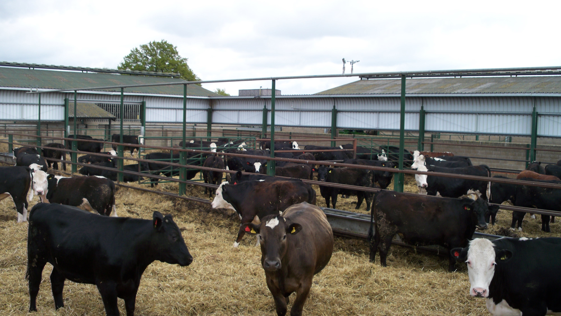
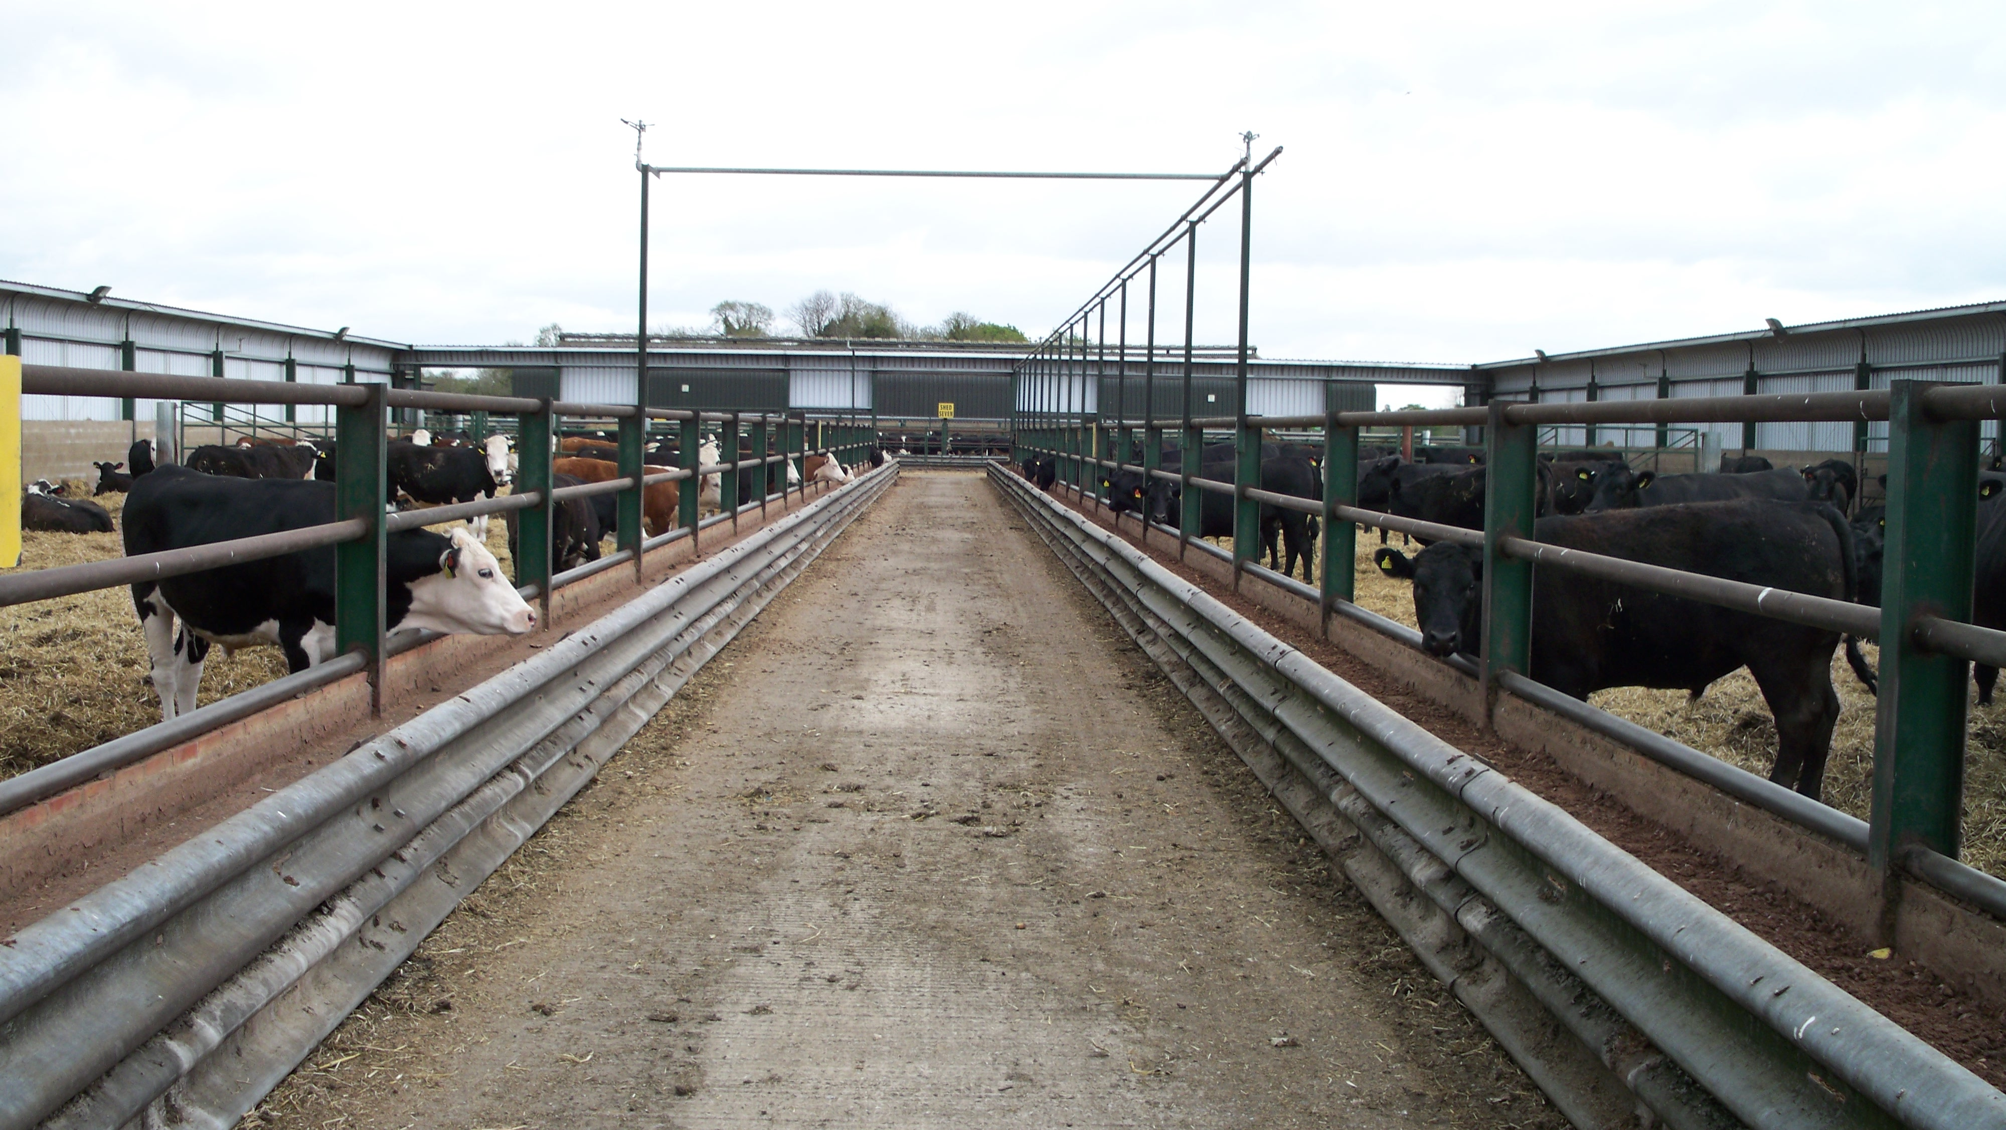
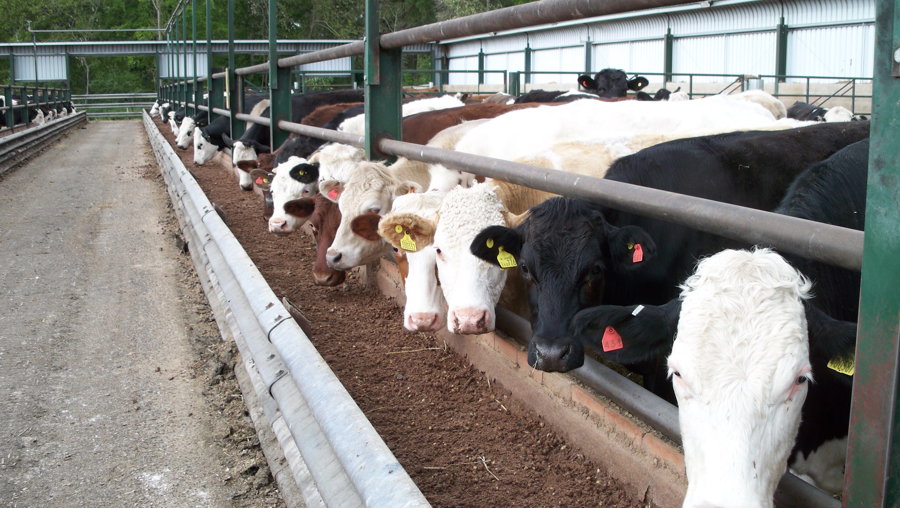

MegaJoules Metabolisable Energy / kg Dry Matter (MegaJoules Ynni Metaboladwy / kg Mater Sych)

